# Rossmoyne Senior High School

### Year 11 Examination, 2015

### Question/Answer Booklet

**SOLUTIONS**

# MATHEMATICS

# METHODS

# UNITS 1 AND 2

## Section One:

## Calculator-free

|  |  |  |  |  |  |  |  |  |
| --- | --- | --- | --- | --- | --- | --- | --- | --- |
| Student Number: In figures |  |  |  |  |  |  |  |  |

In words

Your name

## Time allowed for this section

Reading time before commencing work: five minutes

Working time for this section: fifty minutes

## Materials required/recommended for this section

##### *To be provided by the supervisor*

This Question/Answer Booklet

Formula Sheet

##### *To be provided by the candidate*

Standard items: pens (blue/black preferred), pencils (including coloured), sharpener,

correction fluid/tape, eraser, ruler, highlighters

Special items: nil

## Important note to candidates

No other items may be taken into the examination room. It is **your** responsibility to ensure that you do not have any unauthorised notes or other items of a non-personal nature in the examination room. If you have any unauthorised material with you, hand it to the supervisor **before** reading any further.

## Structure of this paper

|  |  |  |  |  |  |
| --- | --- | --- | --- | --- | --- |
| Section | Number of questions available | Number of questions to be answered | Working time (minutes) | Marks available | Percentage of exam |
| Section One:  Calculator-free | 7 | 7 | 50 | 52 | 35 |
| Section Two:  Calculator-assumed | 12 | 12 | 100 | 98 | 65 |
|  | | | **Total** | 150 | 100 |

## Instructions to candidates

1. The rules for the conduct of examinations are detailed in the school handbook. Sitting this examination implies that you agree to abide by these rules.
2. Write your answers in this Question/Answer Booklet.
3. You must be careful to confine your response to the specific question asked and to follow any instructions that are specified to a particular question.
4. Spare pages are included at the end of this booklet. They can be used for planning your responses and/or as additional space if required to continue an answer.

* Planning: If you use the spare pages for planning, indicate this clearly at the top of the page.
* Continuing an answer: If you need to use the space to continue an answer, indicate in the original answer space where the answer is continued, i.e. give the page number. Fill in the number of the question that you are continuing to answer at the top of the page.

1. **Show all your working clearly**. Your working should be in sufficient detail to allow your answers to be checked readily and for marks to be awarded for reasoning. Incorrect answers given without supporting reasoning cannot be allocated any marks. For any question or part question worth more than two marks, valid working or justification is required to receive full marks. If you repeat any question, ensure that you cancel the answer you do not wish to have marked.
2. It is recommended that you **do not use pencil**, except in diagrams.
3. The Formula Sheet is **not** to be handed in with your Question/Answer Booklet.

Section One: Calculator-free (52 Marks)

This section has**seven (****7)** questions. Answer **all** questions. Write your answers in the spaces provided.

Working time for this section is 50 minutes.

Question 1 (5 marks)

Calculate the value of

(a) . (2 marks)



(b)  when  and , leaving your answer in scientific notation.

(3 marks)



Question 2 (6 marks)

A line has equation . Determine the value of the constant m if the line

(a) is parallel to . (1 mark)



(b) is perpendicular to . (1 mark)



(c) passes through the point of intersection of the lines  and . (4 marks)



Question 3 (8 marks)

(a) A parabola passes through the points (0, 5), (5, 0) and has  as its axis of symmetry.

(i) Sketch the graph of this parabola. (3 marks)

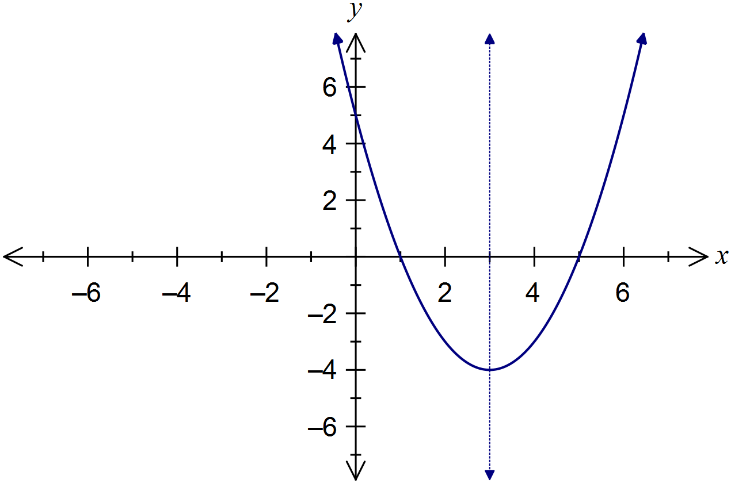

(ii) Determine the equation of the curve in the form . (2 marks)



(b) Determine the discriminant of the quadratic expression  and hence state the number of zeroes of the expression. (3 marks)



Question 4 (8 marks)

(a) State the coordinates of all axes intercepts of the graph of . (2 marks)

(3, 0), (-3, 0), (0, 3) and (0, -3).

(b) State the equation of the axis of symmetry of the graph of . (1 mark)



(c) The graph of a relationship is shown below.

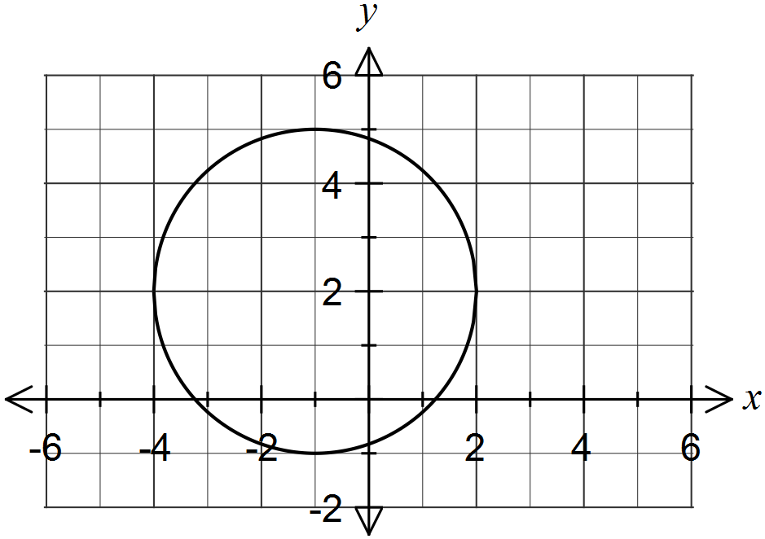

(i) Determine the equation of the graph. (2 marks)



(ii) Calculate the exact coordinates of the positive x-axis intercept. (3 marks)



Question 5 (9 marks)

(a) Determine  for

(i) . (1 mark)



(ii) . (2 marks)



(b) Determine  if . (3 marks)



(c) Determine  if  and . (3 marks)



Question 6 (6 marks)

(a) The graphs of ,  and  are shown below.

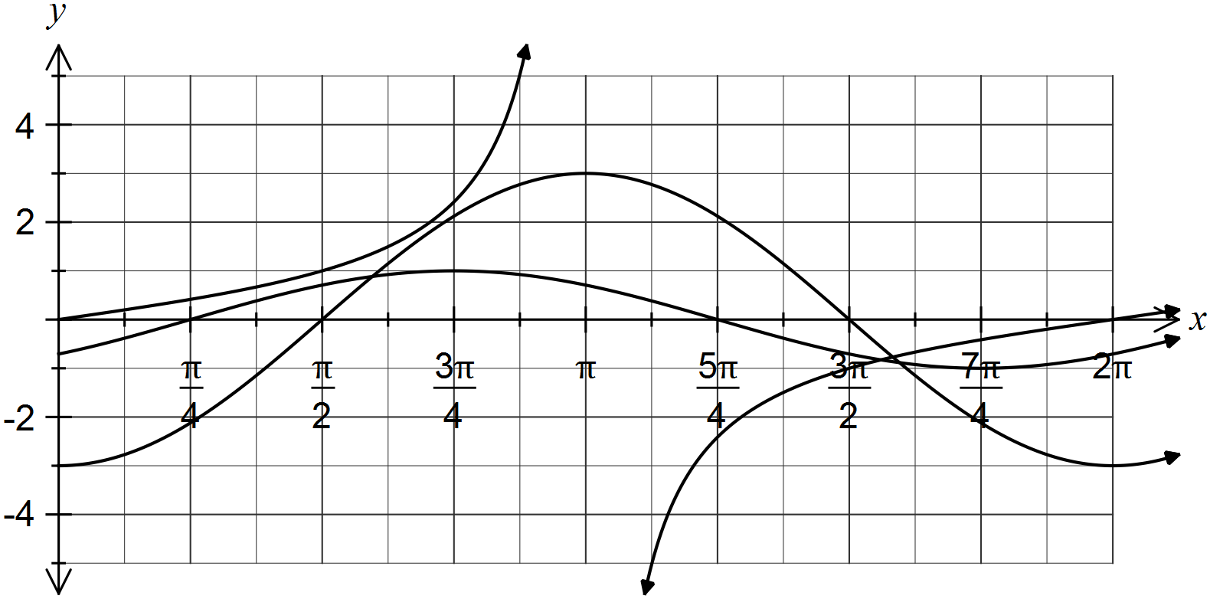

Determine the values of the constants a, b and c. (3 marks)



(b) Solve the equation  for . (3 marks)



Question 7 (10 marks)

(a) Expand . (3 marks)



(b) Solve the following for x:

(i) . (3 marks)



(ii) . (4 marks)



Additional working space

Question number: _________

Additional working space

Question number: _________

This examination paper may be freely copied, or communicated on an intranet, for non-commercial purposes within educational institutes that have purchased the paper from WA Examination Papers provided that WA Examination Papers is acknowledged as the copyright owner. Teachers within Rossmoyne Senior High School may change the paper provided that WA Examination Paper's moral rights are not infringed.

Copying or communication for any other purposes can only be done within the terms of the Copyright Act or with prior written permission of WA Examination papers.

*Published by WA Examination Papers*

*PO Box 445 Claremont WA 6910*